**5 Best Practices for Python Exception Handling**

[[Saad Jamil](https://medium.com/@saadjamilakhtar?source=post_page-----5e54b876a20--------------------------------)](https://medium.com/@saadjamilakhtar?source=post_page-----5e54b876a20--------------------------------)

[Saad Jamil](https://medium.com/@saadjamilakhtar?source=post_page-----5e54b876a20--------------------------------)

·

[Follow](https://medium.com/m/signin?actionUrl=https%3A%2F%2Fmedium.com%2F_%2Fsubscribe%2Fuser%2Fbb08952ac693&operation=register&redirect=https%3A%2F%2Fmedium.com%2F%40saadjamilakhtar%2F5-best-practices-for-python-exception-handling-5e54b876a20&user=Saad+Jamil&userId=bb08952ac693&source=post_page-bb08952ac693----5e54b876a20---------------------post_header-----------)

4 min read

·

Aug 9, 2023

146

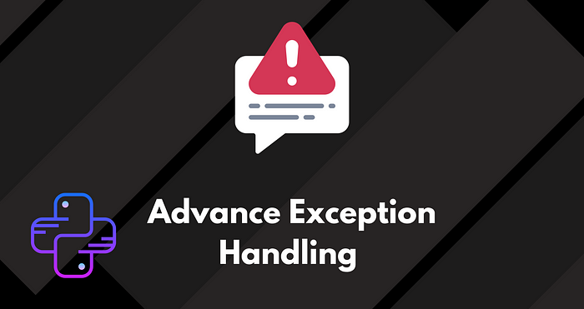

Exception handling is a fundamental aspect of writing robust and reliable Python code. Just like how a skilled driver navigates through unexpected roadblocks, a proficient programmer gracefully handles exceptions to maintain application stability and provide users with meaningful feedback. In this blog post, we’ll explore the best practices and guidelines for effective exception handling in Python. By following these strategies, you’ll be well-equipped to enhance your code’s resilience and provide a smoother user experience.

**1. Use Specific Exceptions**

Catching specific exceptions is akin to using specialized tools for different tasks. Instead of relying on a **generic catch-all statement**, it’s essential to catch specific exception types. This practice allows you to differentiate between various errors and deliver accurate error messages, making issue identification and resolution more efficient.

try:  
 # Code that may raise a specific exception  
 ...  
except SpecificException as e:  
 # Handle the specific exception  
 ...  
except AnotherSpecificException as e:  
 # Handle another specific exception  
 ...  
except Exception as e:  
 # Handle other exceptions or provide a fallback behavior  
 ...

A Real life example would be:

try:  
 with open('data.csv', 'r') as file:  
 csv_reader = csv.reader(file)  
 for row in csv_reader:  
 # Perform some calculations on the data  
 result = int(row[0]) / int(row[1])  
 print(f"Result: {result}")  
except FileNotFoundError:  
 print("The file 'data.csv' was not found.")  
except IndexError:  
 print("Invalid data format in the CSV file.")  
except ZeroDivisionError:  
 print("Cannot divide by zero.")  
except ValueError:  
 print("Invalid value encountered during calculations.")  
except Exception as e:  
 print(f"An unexpected error occurred: {e}")

**2. Implement Error Logging**

Imagine your Python application as a complex puzzle. Error logging acts as your cheat sheet, helping you put the pieces together when things go awry. Utilizing the **logging module**, you can capture exceptions along with vital information like timestamps, error details, and stack traces. This empowers you to analyze errors comprehensively and enhance the reliability of your application.

import logging  
  
# Configure the logger  
logging.basicConfig(filename='error.log', level=logging.ERROR)  
  
try:  
 # Code that may raise an exception  
 ...  
except Exception as e:  
 # Log the exception along with additional information  
 logging.error('An error occurred: %s', str(e))

**3. Define Custom Exception Classes**

Think of custom exception classes as tailored outfits for specific occasions. Python allows you to create custom exception classes that cater to your application’s unique needs. By doing so, you can categorize and encapsulate different errors, leading to better code readability, improved error handling, and modular project development.

class CustomException(Exception):  
 pass  
  
try:  
 if condition:  
 raise CustomException("Something went wrong!")  
except CustomException as e:  
 # Handle the custom exception  
 ...  
except Exception as e:  
 # Handle other exceptions or provide a fallback behavior  
 ...

**4. Handle Exceptions Gracefully**

Handling exceptions gracefully is like being a composed host at a dinner party when unexpected guests arrive. To prevent application crashes and user confusion, employ **try-except** blocks to catch exceptions. This allows you to provide suitable error messages or alternative actions. Graceful error handling enhances user experience, maintains application flow, and safeguards against security vulnerabilities.

try:  
 # Code that may raise an exception  
 ...  
except SpecificException as e:  
 # Handle the specific exception gracefully  
 print("An error occurred:", str(e))  
 # Provide fallback behavior or inform the user  
 ...  
except Exception as e:  
 # Handle other exceptions or provide a generic error message  
 print("An unexpected error occurred.")  
 # Provide fallback behavior or inform the user  
 ...  
else:  
 # Code that executes if no exceptions are raised  
 ...

**5. Use Finally for Cleanup Tasks**

Imagine you’re a responsible party host cleaning up after the festivities. The **finally** block in exception handling serves a similar purpose. It ensures that certain code will execute regardless of whether an exception occurred or not. This is ideal for performing cleanup tasks, such as *closing files or releasing resources, maintaining your application’s integrity*.

try:  
 # Code that may raise an exception  
 ...  
except Exception as e:  
 # Handle the exception  
 ...  
else:  
 # Code that executes if no exceptions are raised  
 ...  
finally:  
 # Code that will always execute  
 # Perform cleanup tasks here  
 ...

Mastering Python exception handling is a vital skill for any programmer. By integrating these best practices into your coding arsenal, you’re building a solid foundation for writing reliable, maintainable, and user-friendly code. Remember to catch specific exceptions, implement error log ing, define custom exception classes, handle exceptions gracefully, utilize the else statement for clean execution paths, and employ the finally block for essential cleanup tasks. With these strategies, you’ll be well-prepared to navigate the challenges of error handling in Python and provide a seamless experience for your users. Happy coding!!

**👍🏻 Like 🔗 share and 👉🏻 follow for more.**